**Richemont Brand Insights — Taiwan vs Global (Oct 2024 – Oct 2025)**

**Prepared by:** Kok Yan Ting | **Data Source:** Google Trends [Untitled spreadsheet - Google Sheets](https://docs.google.com/spreadsheets/d/1oKfkZuMknenX33BVS2v9xeOrz09FiHCbE_4wFxfixRY/edit?gid=573451037#gid=573451037)

## **1. Executive Summary**

This report provides a one-page overview of search interest trends for Cartier and Van Cleef & Arpels in Taiwan compared to worldwide, highlighting key insights and actionable recommendations for local marketing strategies.

**2. Key Metrics**

| **Average** | 77.32 | 68.92 | 51.83 | 24.08 |
| --- | --- | --- | --- | --- |
| **TW/Global Ratio** | 112.18% | - | 215.28% | - |

**Interpretation**:

1. Cartier searches in Taiwan slightly outperform global averages, indicating strong local engagement.
2. Van Cleef & Arpels searches in Taiwan are more than double global averages, reflecting rapid local growth and rising brand popularity.

## **3. Observed Trends**

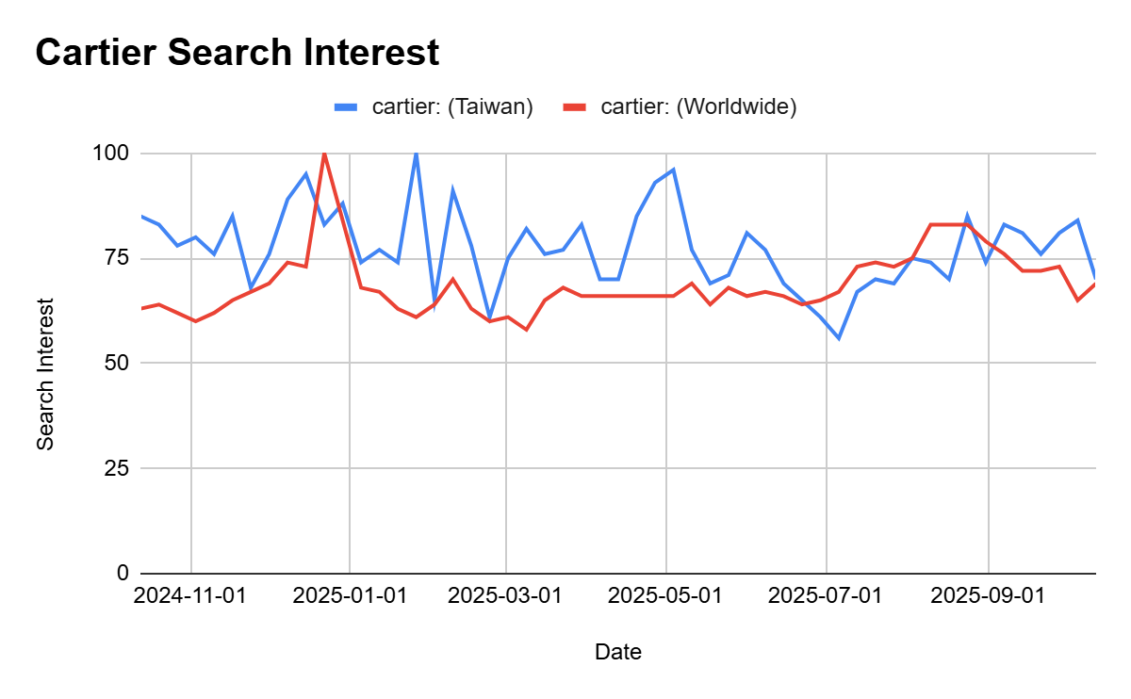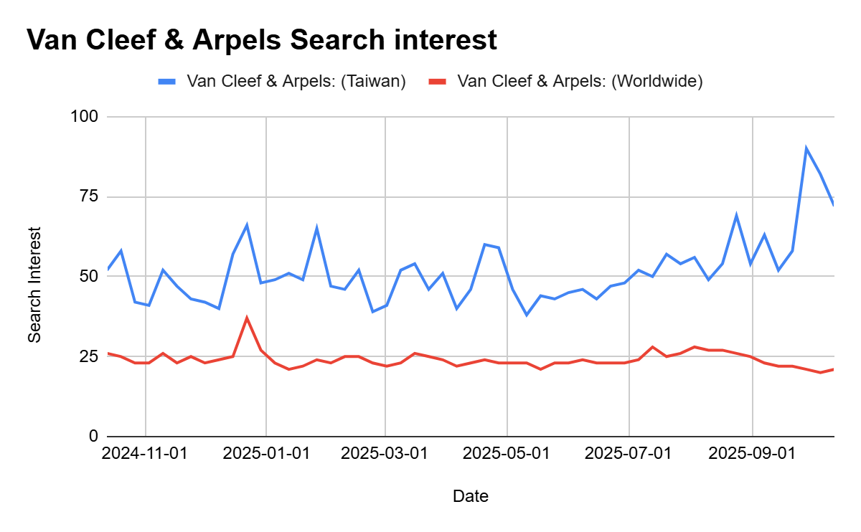

1. **Seasonality:** Both brands show peaks around Lunar New Year, Valentine’s Day, & December holidays.
2. **Cartier:** Consistent interest year-round → mature, stable luxury presence.
3. **Van Cleef & Arpels:** More volatile but increasing interest → emerging opportunity for targeted campaigns.

**4. Recommendations**

1. **Localize campaigns for seasonal peaks:** Launch Cartier promotions 2–3 weeks before Lunar New Year; highlight Van Cleef bridal collections in summer.
2. **Enhance Taiwan-specific storytelling:** Use social media, boutique events, and influencer collaborations to strengthen local engagement.
3. **Monitor trends regularly:** Track search and engagement data quarterly to optimize marketing and product strategies for Taiwan.